**Question 1 Flowchart:**

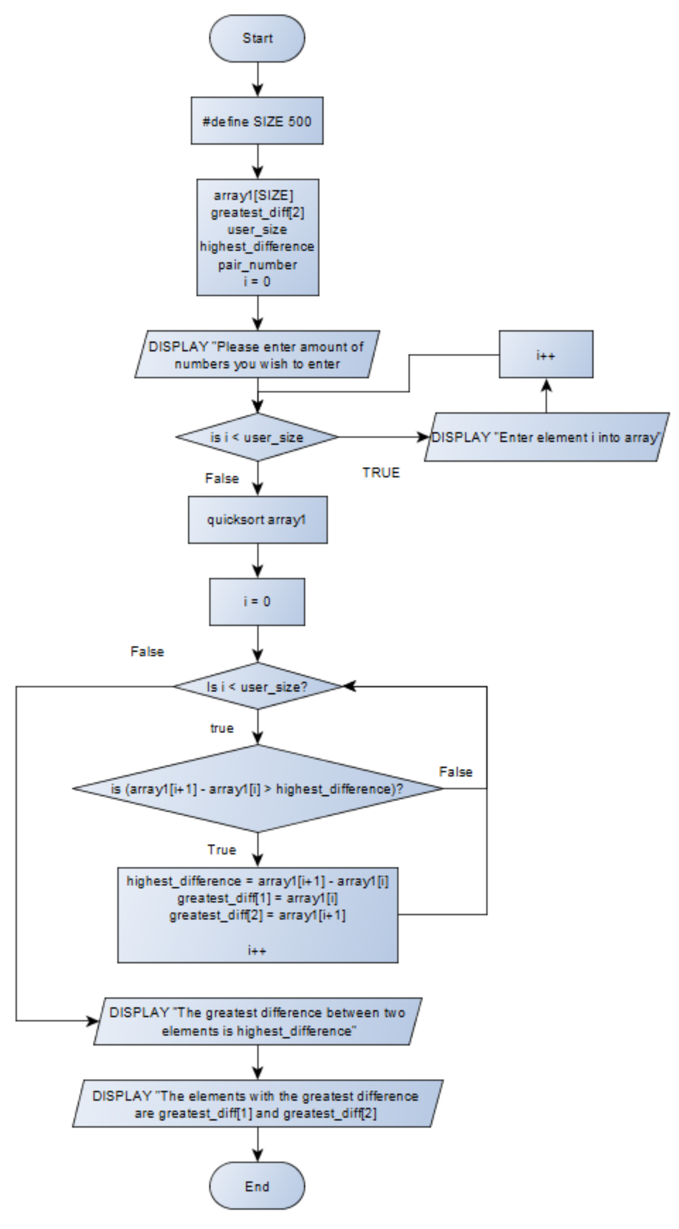

**Question 1 Flowchart Description:**

This flowchart’s logic is simple to understand. First I created a macro definition of 500 so the user can enter as many elements as they would want. Then I set about creating the variables array1[SIZE] will hold the users numbers, greatest_diff[2] which will hold the pair with the greatest difference and highest_difference for displaying the highest difference. I then prompt the user to select how many elements they would like in their array and then I prompt them to enter the array. A quicksort is then carried out and then a loop is set up to check if the pair selected has the highest difference. If the pair has the highest difference it is stored in a variable to then be printed. After this, the program then prints the elements with the highest difference and the actual highest difference.

**Question 2 Flowchart:**

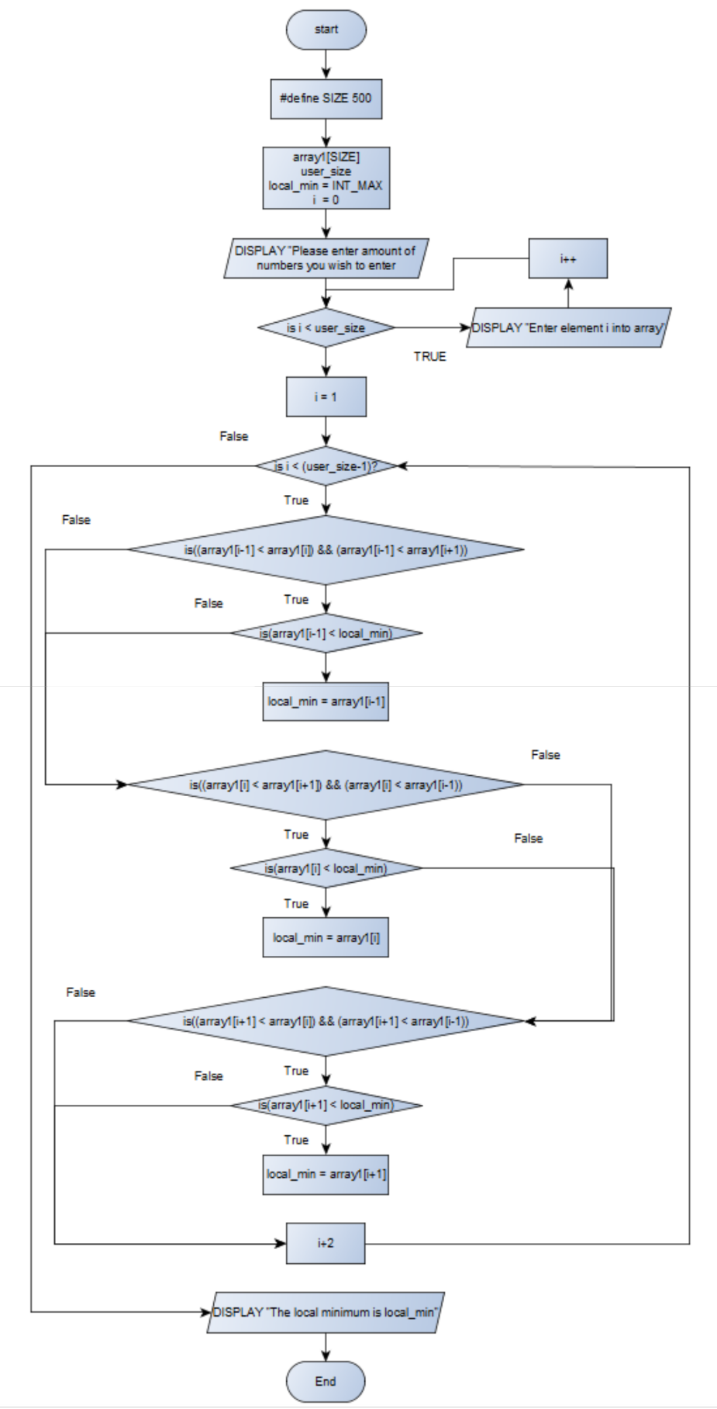

**Question 2 Flowchart Description:**

This flowchart is also easy to understand. This flowchart also uses a macro definition to set SIZE to 500. It also initialises array1[SIZE] to hold the user’s numbers, user_size for the amount of elements the user wishes to use and also local_min = INT_MAX which sets local_min to the highest possible int value. The user is then prompted to enter numbers into the array and a loop is then executed to allow them to enter elements into the array. I is then set to one and a loop containing the condition of “is i<(user_size-1)” is used to execute the check for the local minimum. This loop checks for the local minimum by checking the element before array1[i] and the element after array1[i] to see if it is the smallest. This can be seen in the flowchart and if a number is the smallest of its group and smaller than local_min it is placed in local_min. I then increment by 2 until the condition is met. The local_min variable is then displayed for the user to see.